**HIGH LEVEL PROGRAMMING EXTENSIONS-FUNCTIONS**

Ex:No: 17

Date:

Aim:

To implement Functions using program in MySQL.

1. Create a function:

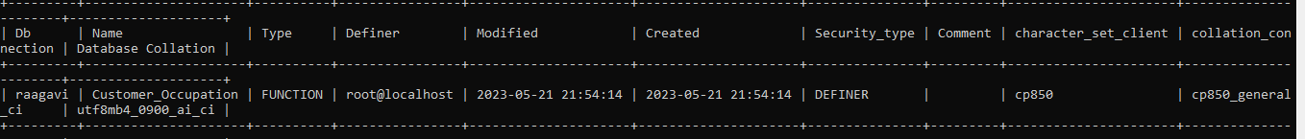

2)call a function;

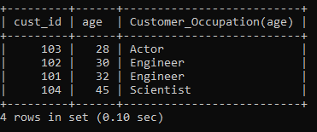

RESULT:

Thus the Functions using program in MySQL executed successfully .